Dear Parents
Alongside the use of Seesaw app we have set up access for G- Suite for Education for our younger children(this includes Google Classroom). In the event of the class having to self-isolate or the school having to go into a lockdown, the staff will be use them in tandem, with live sessions on Google Classroom and activities for children set via the Seesaw app. Our year 6 pupils successfully used G-Suite for Education with Mrs Cartwright when they recently had to self-isolate for 14 days. A sticker with your child’s login details for G-Suite can be found in the front of the new red homework book which will be sent home tomorrow along with instructions/learning codes for Seesaw.
There are a lot of videos about google classroom out there for parents –this one is quite short and to the point.
Parent Guide to Google Classroom - https://www.youtube.com/watch?v=2Iowi-gmbys
If children will be using iPads/Android at home you will need to download all of the Google Apps first, from Apple App store/ Google Play Store (see below) even though they will not be using all the apps:
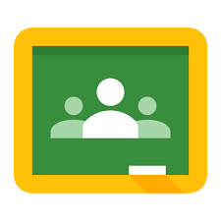 | 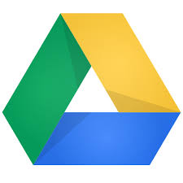 | 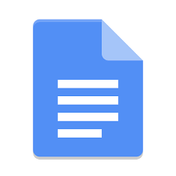 | 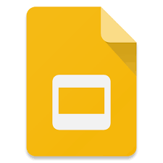 | 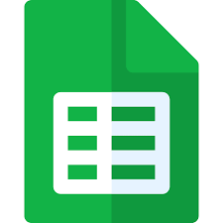
Google Classroom | Google Drive | Google Docs | Google Slides | Google Sheets

To set up from ipad/tablet:
- Load up Google Classroom
- Press ‘Get Started’
- Log in using the details you have been given by your school
- Click ‘Accept’. You may have to scroll down.
- Press ‘I’m a Student’
- It is up to you if you would like to accept Notification. Press either ‘Don’t Allow’ or ‘Allow’
- You will now see your class. Click Join. If any classes you are not part of are listed, click Decline
If you have any issues with your logins or problems setting up, please email the school office:
admin@waverton.cheshire.sch.uk
Yours sincerely,

Mr S Talbot
Headteacher

