Logging in to Google Classroom from a PC
- Load up you web browser (preferably Google Chrome)
- Go to classroom.google.com
- Click the ‘Go to Classroom’ button
- Log in using the details you have been given by your school
- Click the ‘Accept’ button
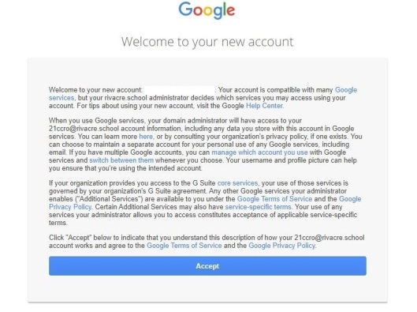

- You will then be prompted to join Google Classroom, click ‘Continue’
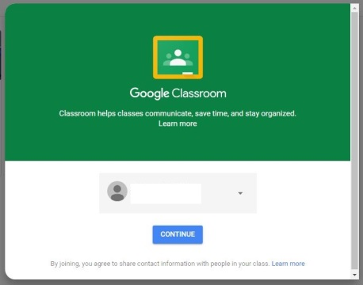

- Click ‘I am a Student’
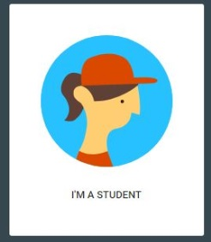

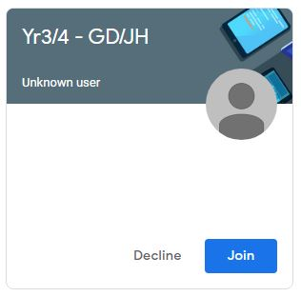
- You will now see your class. Click Join. If any classes you are not part of are listed, click Decline.

