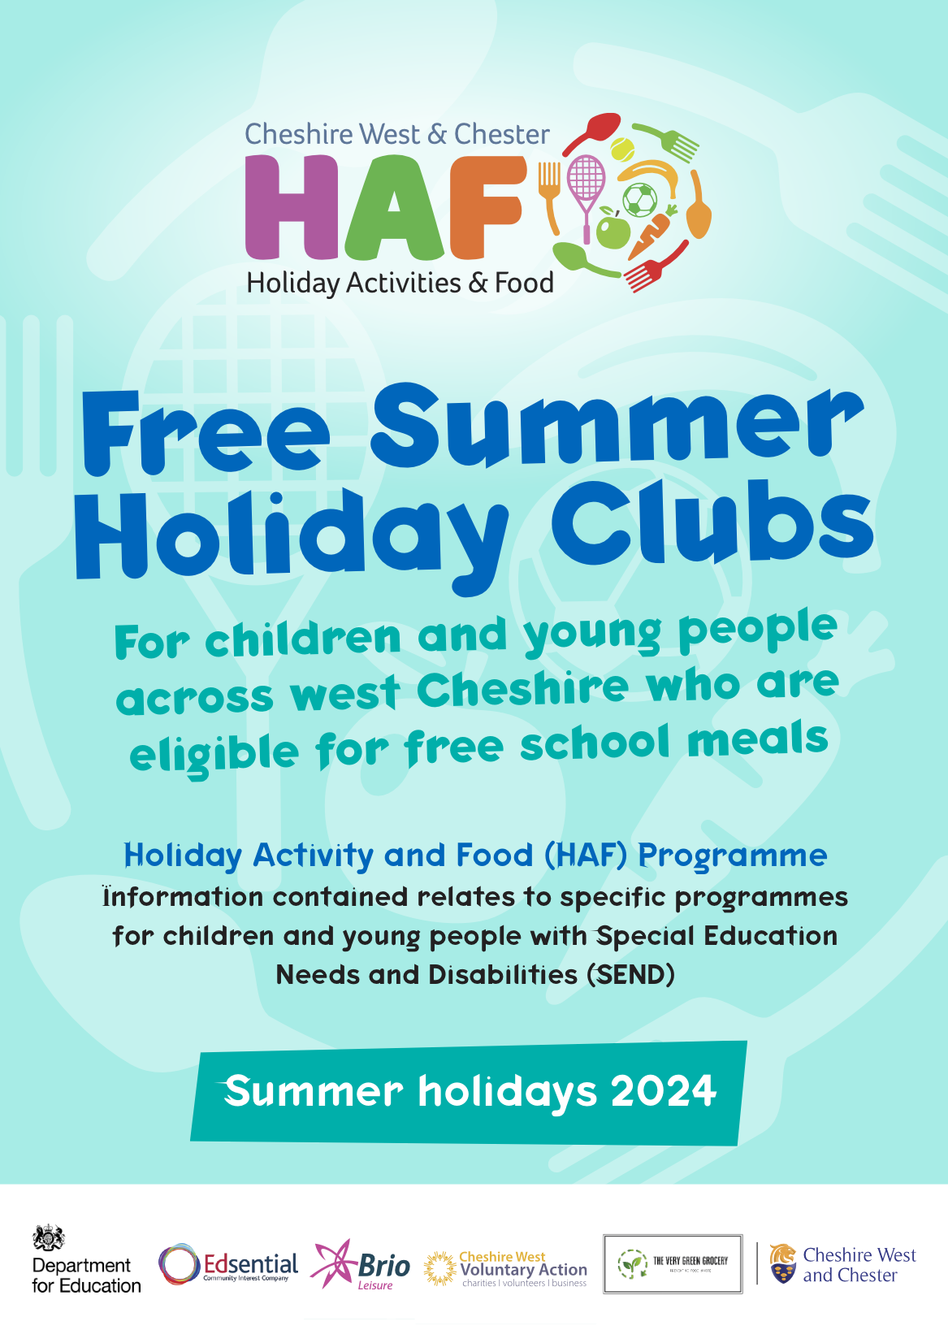

Cheshire West and Chester Council offer SEND specific HAF sessions. Sessions will take place throughout this borough over the Summer period.

Details of each offer can be seen within this booklet.

**Sessions are designed to be free for Children with SEND who are on benefit-related Free School Meals. There is also an opportunity for Children who are not on Free School Meals to pay for places. To find out the costs of any places detailed within this booklet for those who are not on Free School Meals, please contact the provider directly through their contact details provided within this booklet.**

Parents/carers will not be charged, to attend or support their child at any session.

There may be opportunities, at some of the HAF providers, to accommodate siblings (Please contact the provider you are choosing to discuss in further detail).

All sessions will come with the provision of a healthy food option as part of the HAF offer, which could consist of either hot or cold food dependent on the session and

location of delivery.



Any queries in relation HAF – SEND provision then please email.

[AimingHighForDisabledChildren@cheshirewest.gov.uk](mailto:AimingHighForDisabledChildren@cheshirewest.gov.uk)

Please also refer to link / QR code for all programmes being delivered across the borough which may be suitable for your

child and their needs, we advise that you contact the club directly to ensure that your child’s need can be met, or that the club can make reasonable adjustments prior to attendance.

<https://edsential.com/haf-cheshire-west/>

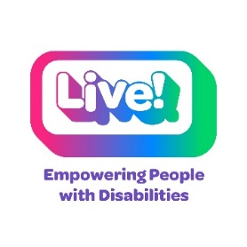**Live! – Chester**

**Activities for SEND children and young people aged 11-18 years**

Throughout the Summer holidays, Live! will be delivering activities such as cooking/baking, keeping fit and healthy, adapted cycle/sports sessions, arts and crafts, and trips out.

**Dates** – 29th July 2024 – 23rd August 2024 (Mondays, Tuesdays, Thursdays, and Fridays all from 10.00am – 2.00pm)

**Venue** – New Scene Centre, Limewood Close, Newton, Chester, CH2 2HD

For more info or to book, please **call 01244 320479 or email** [karen@livecheshire.org.uk](mailto:karen@livecheshire.org.uk)

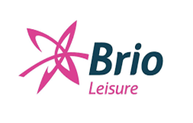**Brio Leisure Ellesmere Port, Northwich and Winsford**

**Activities for SEND children and young people aged 5-18 years**

Throughout the Summer Holidays, Brio Leisure will be delivering Fun and Floats, Multi-Sport Activities and Food 5 – 18 years

**(Age 5 to 6 years - Fun and Floats only)**

Children and young people must be assisted in the above activities. If required, parents/carers and siblings can take part without charge

Swimming aids are available at each site if needed

For our Fun and Floats session, normal swimming pool rules apply

**Children aged 5 – 7 years inclusive**

1 adult: 2 children with or without approved floatation aids

**Children aged 8 years and over**

**Northwich Memorial Court**

**Dates:**

**31st July; 07th August;**

**14th August; 21st August**

For more info or to book, please **email**

[**NorthwichMC@brioleisure.org**](mailto:NorthwichMC@brioleisure.org)

**Or call Contact number**

01606 261100

**Fun and Floats**

10.30 - 12.00

**Crafts and Lunch**

12.15 - 13.30

**Ellesmere Port Sports Centre**

**Dates:**

**07th August; 14th August; 21st August; 28th August**

For more info or to book, please **email**

[**EPSportsVillage@brioleisure.org**](mailto:EPSportsVillage@brioleisure.org)

**Or call Contact number**

0151 659 1010

**Fun and Floats**

10.30 - 11.30

**Lunch** 12.00 - 12.30

**Multi Sports/craft**

12.30 - 1.30

**Winsford Lifestyle Centre**

**Dates:**

**07th August; 14th August; 21st August; 28th August**

For more info or to book, please **email**

[**Winsford@brioleisure.org**](mailto:Winsford@brioleisure.org)

**Or call Contact number**

01606 261100

**Lunch, Bouncy castle, Interactive Wall, and Crafts**

12.30 – 2.15

**Fun and Floats**

2.30 - 3.30

**Edsential Community Interest Company**

**Activities for SEND children and young people aged 8-14 years**

Throughout the Summer Holidays, Edsential CIC will be delivering fully energised sessions with activities for all abilities and interests. These will include outdoor learning, forest school, arts, crafts, and cooking.

***Parents are not required to attend these sessions.***

***Please note change in location, all activities will remain the same which families may find a more convenient location to get to. This information has also been amended on the central Edsential website***

**Dates:** 01st August; 05th August; 07th August; 09th August

**Venue:** Bridge Community Wellness Gardens, Mill Lane, Ellesmere Port, CH66 3NE

For more info or to book, please **call** **0151 541 2170 or email** [**Lotc@edsential.co.uk**](mailto:Lotc@edsential.co.uk)

**Sean Bailey Wellness Community Interest Company**



**Activities for SEND children and young people aged 8-14 years**

Throughout the Summer Holidays, Sean Bailey Wellness CIC will be delivering Sports, physical activity, art, drama, performing arts, Lego, chill out zone, sensory play space, sensory activities.

***Please also see poster included.***

**Dates:** 22nd July-25th July; 29th July-01st August; 05th August-08th August; 12th August-15th August

**Venue:** Queens Park High School, Handbridge, Chester,CH4 7AE

For more info or to book, please visit: [**https://seanbaileywellness.com/community-camps-chester/**](https://seanbaileywellness.com/community-camps-chester/)

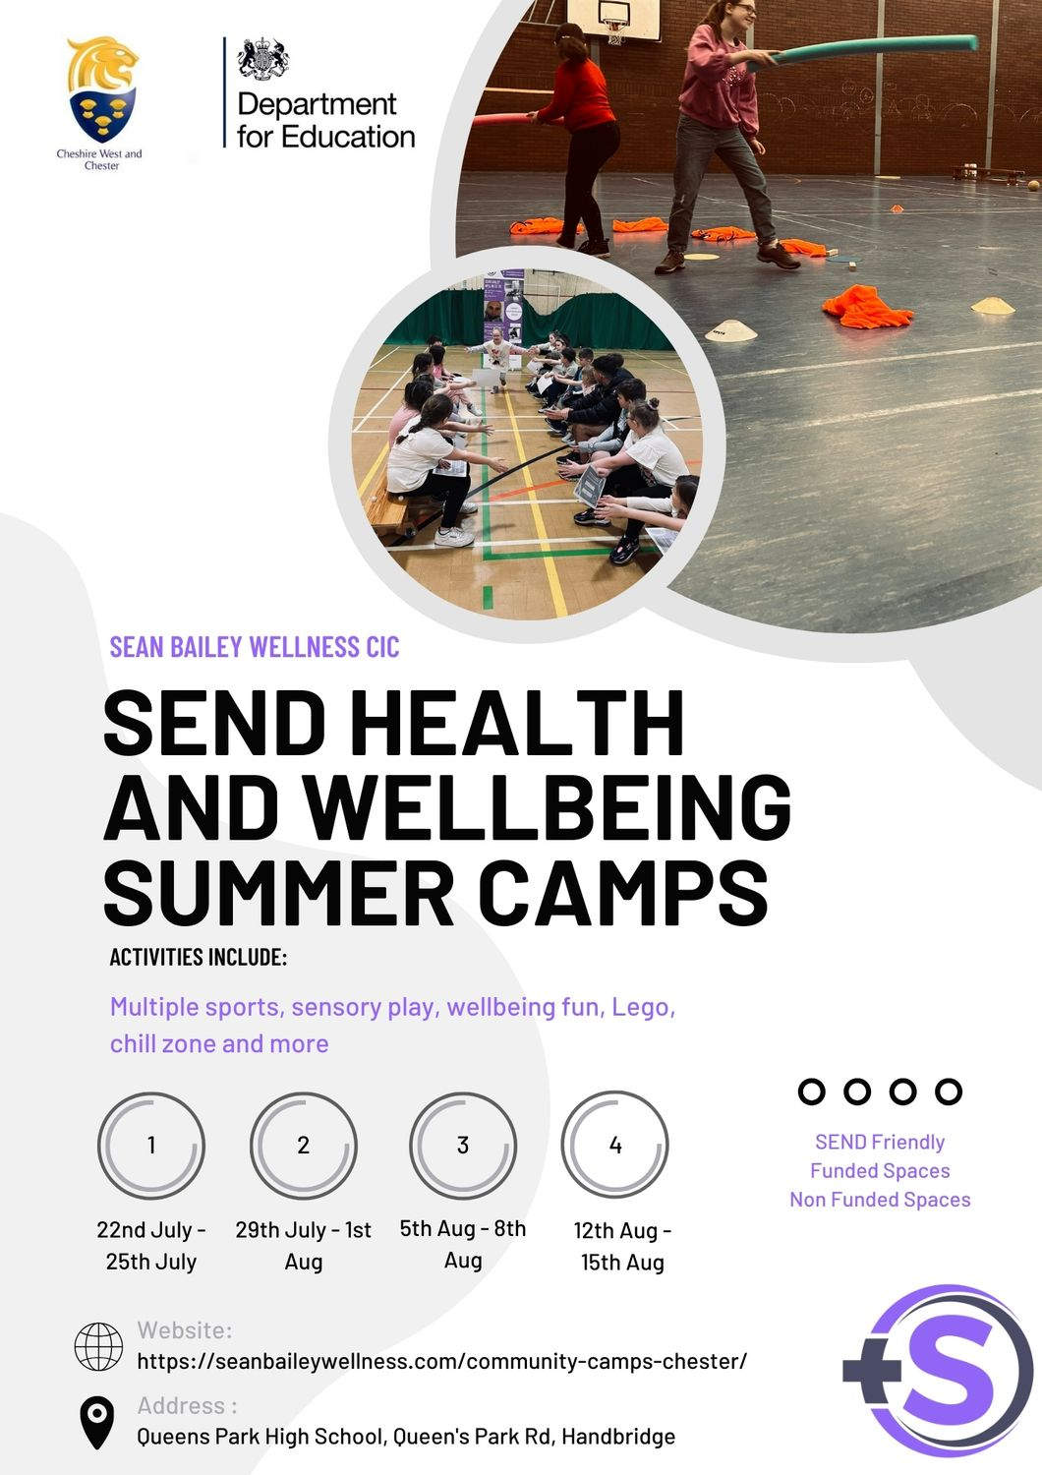

**SEND Choices**

**Activities for SEND children and young people aged 11+ years up to 25 if SEND (Special Educational Needs and Disability)**

SEND Choices Youth Projects offers a welcoming environment for young people to socialise with their friends, peers and meet new people. We provide tailored programme plans that meet the needs of young people, encouraging engagement and participation in developing social skills, life skills and independent living, you do not need to register you can turn up at provisions and enjoy the evening:

Northgate Locks Resource Centre, Canal Street, Chester, CH1 4EJ

**Wednesday’s - 07th August; 14th August; 21st August; 28th August**

**6.30pm to 8.30pm**.

If you want to find out more, please email [**clare.watson@cheshirewest.gov.uk**](mailto:clare.watson@cheshirewest.gov.uk)

Choices SEND Project, Salvation Army, Whitby Road Whitby, Ellesmere Port, CH65 6RS

**Thursday’s 08th August; 15th August; 22nd August; 29th August 6.30pm to 8.30pm**

If you want to find out more, please email [**leanne.owen@cheshirewest.gov.uk**](mailto:leanne.owen@cheshirewest.gov.uk)

New Images Centre, Nixon Drive Winsford CW7 2HG

**Thursday’s 01st August; 08th August;15th August; 22nd August; 29th August 7.00pm till 9.00pm**

If you want to find out more, please email [**dean.latham@cheshirewest.gov.uk**](mailto:dean.latham@cheshirewest.gov.uk)

Northwich & District Youth Centre, Winnington Lane Northwich CW8 4DE

**Monday’s 05th August; 12th August; 19th August; 26th August**

**7.00pm till 9.00pm**

If you want to find out more, please email [**dean.latham@cheshirewest.gov.uk**](mailto:dean.latham@cheshirewest.gov.uk)